The Three Wise Monkeys (100 points)
Create a Web page (HTML5 + CSS3) that looks and behaves like the screenshot below:
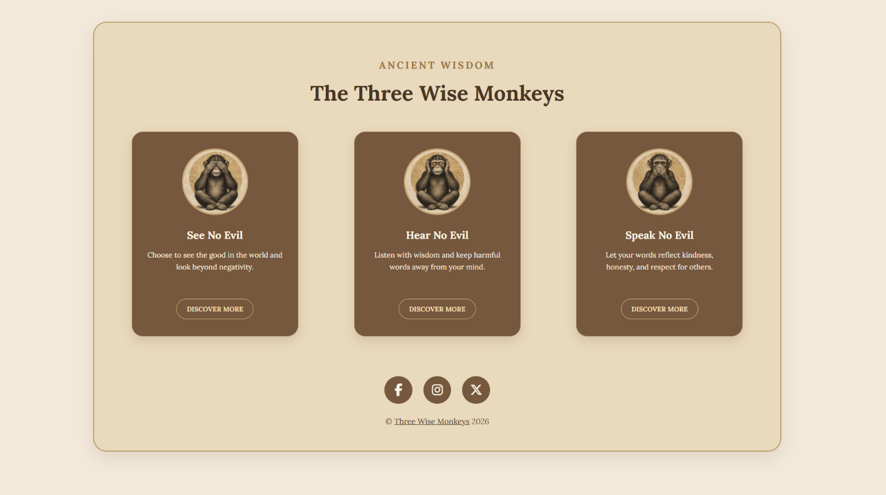

Output
The output should be valid HTML5 + CSS3 + Font Awesome icons that implement the above web page.
- Use font 'Lora', sans-serif - already imported in the CSS file.
- The site should open correctly in the latest version of Chrome

IMPORTANT: Do not change the structure of the provided exam resources. You may create files, but do not create new folders, rename existing ones, or move them to other directories.

Hints:
- Background: Use a color picker tool to identify the background color of the image and apply it to the frontend design.
- Icons with Font Awesome: Use Font Awesome to add the following icons to your frontend design: X (Twitter), Facebook, Instagram.

